Q. Create the following tables with the given structures and insert sample data as specified.

A) SALESPEOPLE:-

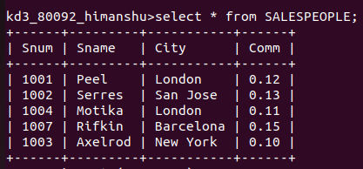
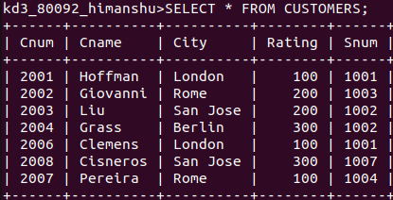
B) CUSTOMERS:-
C) ORDERS:-
